Lab 2 - Building Serverless Applications with Spring Cloud Function

**Step 1: Set up a Spring Boot project**

1. Open your preferred Integrated Development Environment (IDE).

2. Create a new Spring Boot project from the Spring Initializr web site.

3. Configure the necessary dependencies for Spring Boot and Spring Cloud Function in your project's `pom.xml` file.

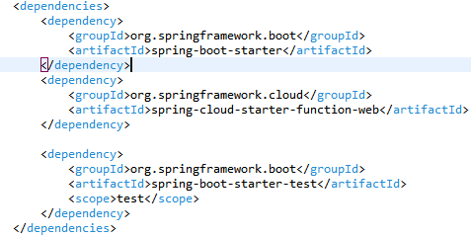

**Step 2: Define your functions**

1. Create a new Java class for each function you want to implement. For example, create a class called `UpperCaseFunction`.

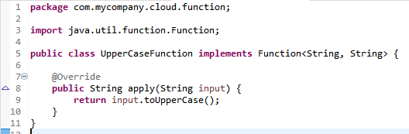

**Step 3: Configure the function endpoints**

1. Create a configuration class annotated with `@Configuration` to define the function endpoints. For example, create a class called `FunctionConfig`.

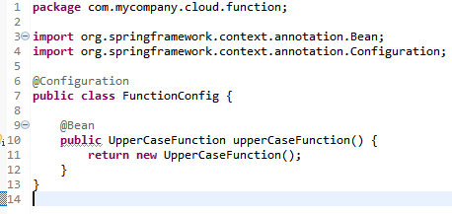

**Step 4: Test the functions**

1. Start your Spring Boot application.

2. Test the function by invoking it through an HTTP request.

3. For HTTP invocation, you can use tools like curl, Postman, or your preferred REST client to test the endpoints.

4. Send a POST request to the `/functions/upperCaseFunction` endpoint with a JSON payload containing the input value.

{

"input": "hello world"

}

```

1. Verify that the response contains the expected result, which is the input string converted to uppercase.

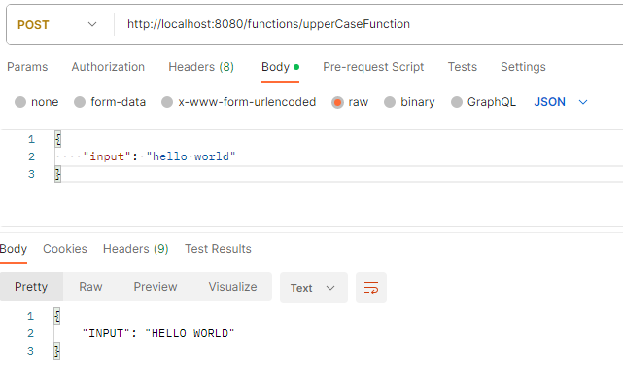

Congratulations! You have successfully completed the lab exercise on setting up and implementing Spring Cloud Function. This exercise covered the basic steps, but there are many more advanced features and configurations available with Spring Cloud Function that you can explore further.

**********************************************************************************************************